SF.SmokeTestScripts_TC_SF_OBRequiredFieldsOnSalesStage_Instance1_12-Apr-2017_10-16-31_PM_Invoke_Application.png



SF.SmokeTestScripts_TC_SF_OBRequiredFieldsOnSalesStage_Instance1_12-Apr-2017_10-16-41_PM_Login.png

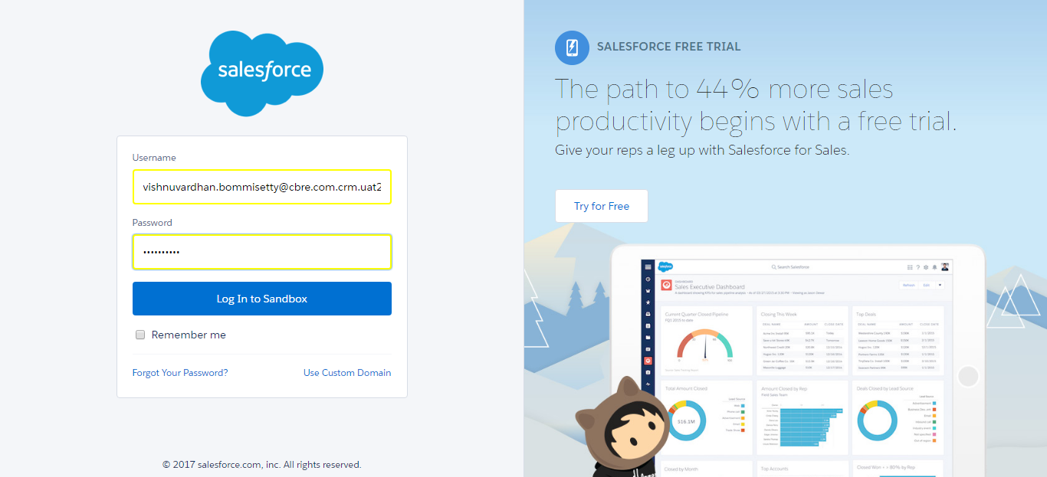

SF.SmokeTestScripts_TC_SF_OBRequiredFieldsOnSalesStage_Instance1_12-Apr-2017_10-16-51_PM_Verify_Login.png

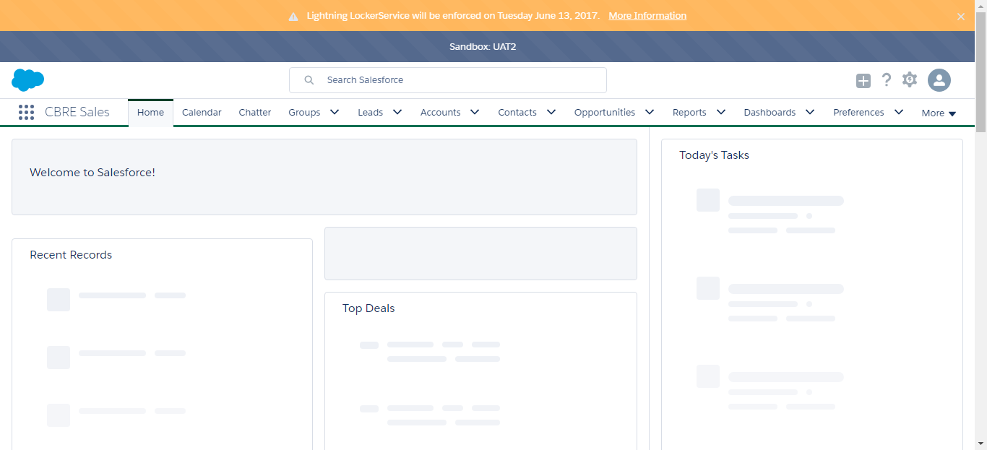

SF.SmokeTestScripts_TC_SF_OBRequiredFieldsOnSalesStage_Instance1_12-Apr-2017_10-16-53_PM_Verify_Fetch_Record.png

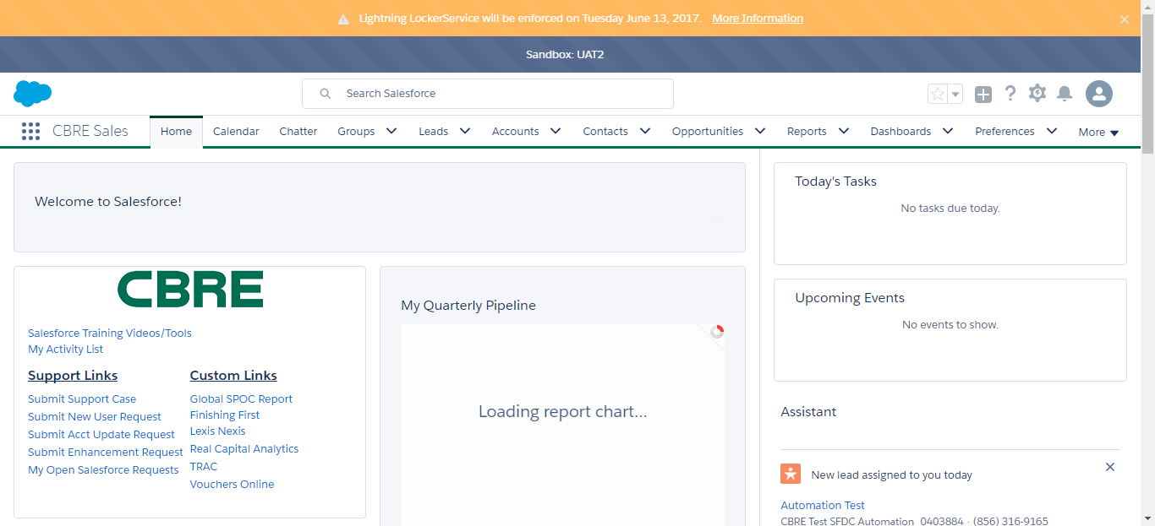

SF.SmokeTestScripts_TC_SF_OBRequiredFieldsOnSalesStage_Instance1_12-Apr-2017_10-16-58_PM_Verify_Add_Opportunity_Page

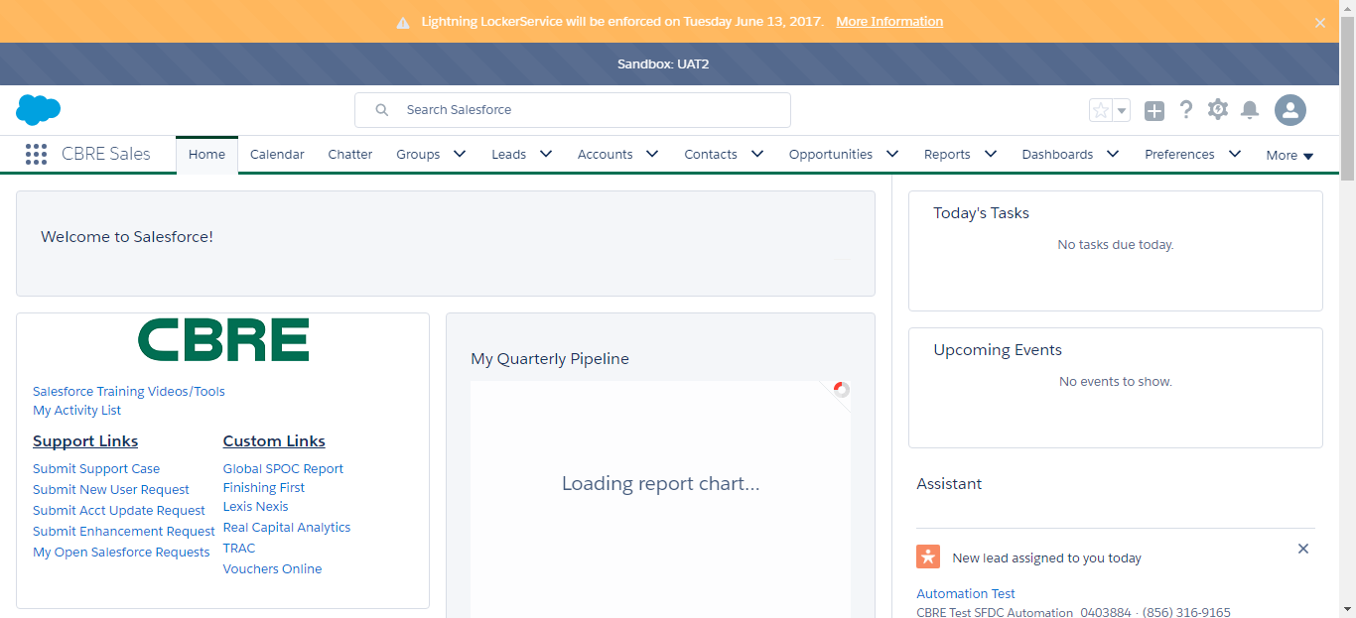

SF.SmokeTestScripts_TC_SF_OBRequiredFieldsOnSalesStage_Instance1_12-Apr-2017_10-16-58_PM_Verify_Opportunity_Required

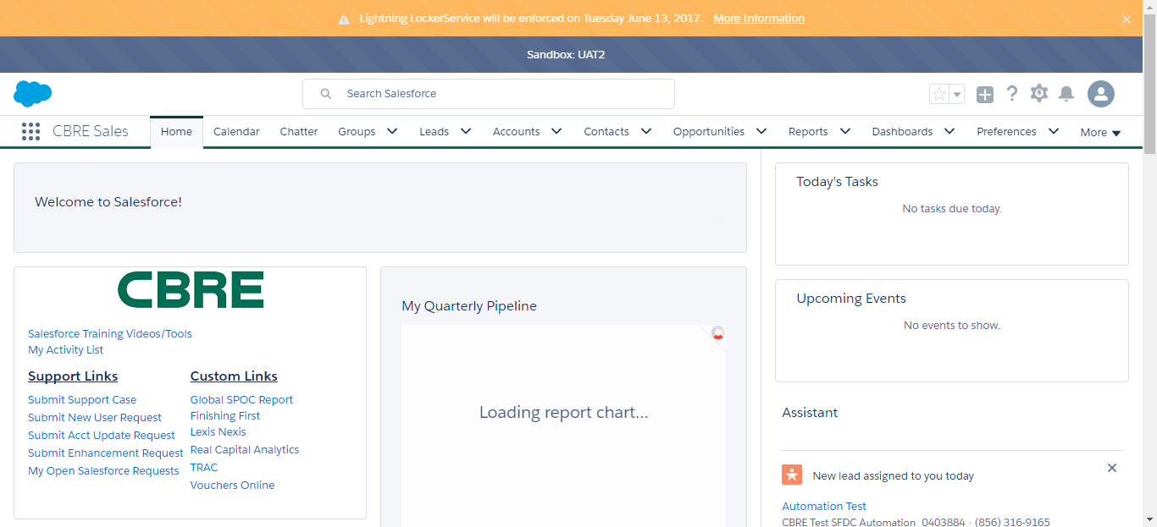

SF.SmokeTestScripts_TC_SF_OBRequiredFieldsOnSalesStage_Instance1_12-Apr-2017_10-17-17_PM_Verify_Add_Opportunity_Page

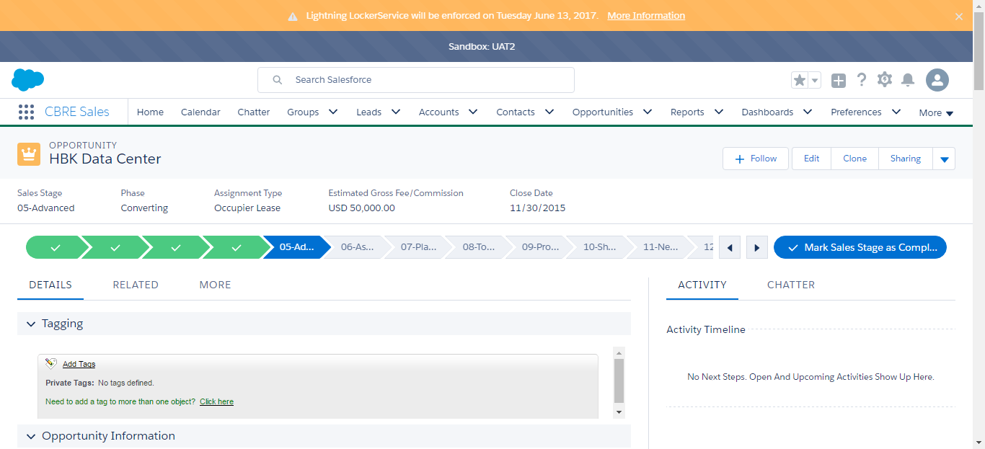

SF.SmokeTestScripts_TC_SF_OBRequiredFieldsOnSalesStage_Instance1_12-Apr-2017_10-17-53_PM_Error.png

